

Assessment Cover Page
Student Full Name | Ridney Gomes Barbosa da Silva
Student Number | 2025417
Module Title | Statistical Techniques for Data Analysis
Assessment Title | Student success and health
Lecturer/Supervisor | Dr. Shree Krishna Acharya
Assessment Due Date | 01 November, 2025
Date of Submission | 23 December, 2025
Use of AI Tools
Choose the statement that fits your work and delete the other.
I acknowledge the use of Gemini (Google) for the purpose of “reference style, review of grammar and punctuation”.
I have not used any AI tools or technologies in the preparation of this assessment.
Declaration
By submitting this assessment, I confirm that I have read the CCT policy on academic misconduct and understand the implications of submitting work that is not my own or does not appropriately reference material taken from a third party or other source.
I declare it to be my own work and that all material from third parties has been appropriately referenced.
I further confirm that this work has not previously been submitted for assessment by myself or someone else in CCT College Dublin or any other higher education institution.


STUDENT SUCCESS AND HEALTH

RIDNEY GOMES BARBOSA DA SILVA

Capstone Project Proposal presented as a partial requirement for approval in Statistical Techniques for Data Analysis discipline of Higher Diploma in Data Analytics for Business at CCT College.
Lecture: Dr. Shree Krishna Acharya

Dublin, 2025

LIST OF IMAGES

Figure 1 . Showing Missing Values 4
Figure 2 . Statistics 4
Figure 3 . The Descriptive Statistics Table 5
Figure 4 . Individual Habits 5
Figure 5 . Average Time Spent 6
Figure 6. Sleep Distribution 6
Figure 7. Shapiro Wilk Test 7
Figure 8. Covariance 8
Figure 9. Probability Student is Stressed 9
Figure 10. Evaluation of Accuracy 9
Figure 11. Variance, Covariance Matrix, Medical Score 10
Figure 12. Heatmap 10

Contents
Summary
1. Data import 4
2. Descriptive Statistics 5
3. Hypothesis Testing metrics 7
3.1 Normality 7
3.2 Parametric Test Anova 7
3.3 Non-Parametric Test 8
4. Analysis: Bayes Theorem 8
5. Regression Model 9
6. Medical Analysis 9
References 11

Data import
The analysis starts began by importing the libraries and reading the dataset, pandas for data manipulation and numpy for numerical calculation also scipy.stats and statsmodels for statistical testing. The dataset student_performance_dataset.csv was loaded into a dataframe to check and get an overview preliminary of was verified using .isnull().sum() to identify missing values.

Figure 1. Showing Missing Values
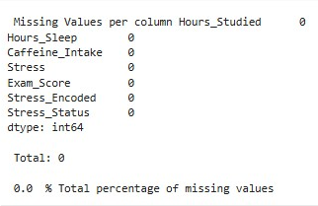

Source: (Author’s Own, 2025)
As shown in the output below, the dataset was found to be complete with zero missing values across all columns, ensuring checked at the unique values, number of rows and columns to subsequently analyses.
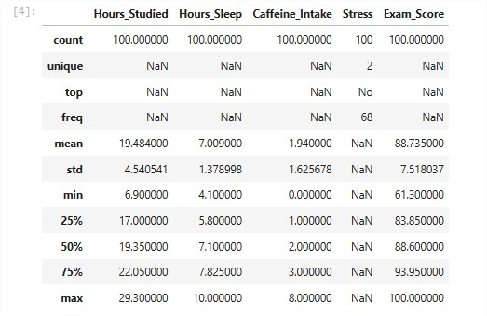
Figure 2. Statistics

Source: (Author’s Own, 2025)
Set of mixed types and shape on the dataset distribution, included “NaN” values to analyse numeric such as float, int and objects types with more details.

Descriptive Statistics
To understand the central tendency and dispersion of the data a descriptive statistic has required to overview the characteristic of measures. Calculated the Mean, Median, and Mode for all columns, also converting column Stress which contains as “yes” and “no” values using dictionary mapping technique has a process of encoded, necessary to conduct the descriptive analyses.
Figure 3. The Descriptive Statistics Table
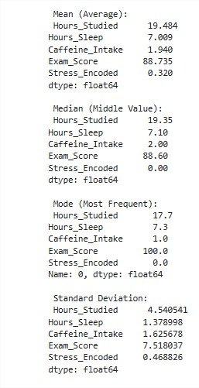
Source: (Author’s Own, 2025)
At figure 3 the screenshot shows all columns grouped by calculus of mean, median, mode and standard deviation of all dataset

Figure 4. Individual Habits
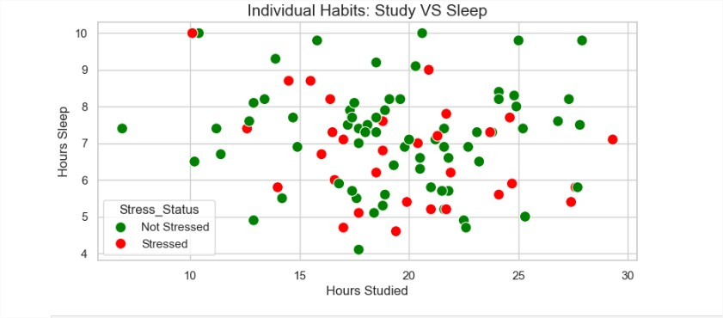
Source: (Author’s Own, 2025)
At figure 4 column created called “Stress_Status” to make the data more readable for plot, “No”, “Yes” converted to Not Stressed and Stressed for yes using. Map function has was described before, process of data transformation to plot and get better understand of the data.
The column “Hours_studied” associetad to axis “x” and “Hours_sleep” to “y” compare and see the correlation if the student ow study more sleep less and are more stressed expressed by red dots, green to not stressed.
Figure 5. Average Time Spent
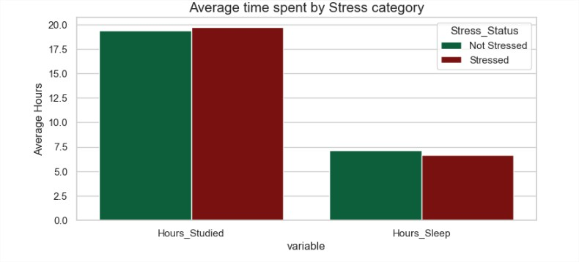
Source: (Author’s Own, 2025)
At figure 5 both columns mentioned on a previous graph is associated to a variable witch contains “Hours_Studied” and “Hours_Sleep” measure the study time and sleep time separated by rows.
Figure 6. Sleep Distribution
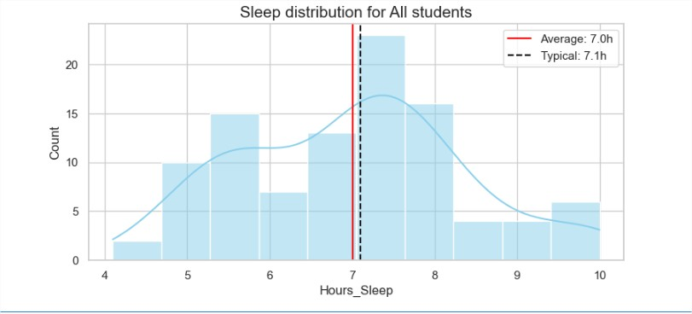
Source: (Author’s Own, 2025)
At figure 6 draws a vertical line across the plot to display the black line represent the median value of Hours Sleep of students and red one the mean, that indicates the data is skewed, consequence of influence by outliers, if was together will be a normal distribution.

Hypothesis Testing metrics

3.1 Normality
Figure 7. Shapiro Wilk Test
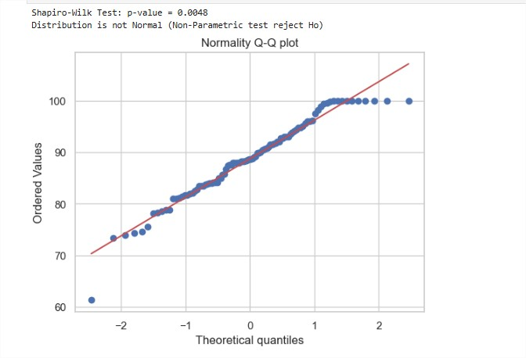
Source: (Author’s Own, 2025)
Before selecting a statistical test to compare exam scores between "Stressed" and "Non-Stressed" students, a Shapiro-Wilk test was performed to check the distribution normality. The test returned p values less than 0.05 for both groups, indicating that the data is not normally distributed.

3.2 Parametric Test Anova
Figure 8. Covariance
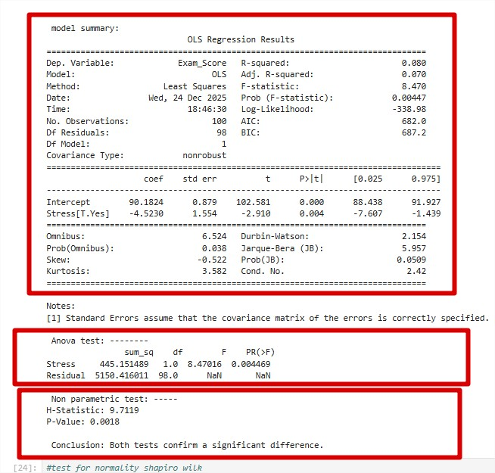

Source: (Author’s Own, 2025)
The non normal distribution a One-Way ANOVA Analysis of Variance was handled as a parametric baseline to test if the mean exam scores differ significantly between the two groups. The OLS model was fitted using “Exam Score ~ Stress” which does is check if the categorical variable Stress predict the continuous variable Exam. Based on the results give in a p value of roughly “0.0045”, rejecting the null hypothesis and indicating a significant difference in means of two groups are significant different.

3.3 Non-Parametric Test
The data isn’t bell shaped violating the normality assumption that was confirmed by the “Shapiro Wilk” test, for solution based on the sample size the non-parametric Kruskal Wallis test was selected as method to compares median ranks rather than means.
The Kruskal Wallis test resulted in a p-value of 0.0018. So, p < 0.05 confirms that the difference in exam performance between “stressed” and “non stressed” students is statistically significant validating the findings of the parametric test compare the median of groups rather the OLS model with the means, ranking the lowest to highest to see if one group rank higher or not than other.

Analysis: Bayes Theorem
To address the reliability of the stress-detection app “Bayes Theorem” was implemented in Python. Defined the prior probability of stress as “p/s” = 0.25 and the app's sensitivity “True positive rate” as “p f/s”: 0.80, the false positive rate was set to 0.10.
Figure 9. Probability Student is Stressed
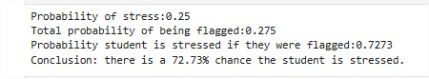
Source: (Author’s Own, 2025)
At figure 11 is calculated the total probability of a flag “P Flag” for anyone, stressed or not combine true positive and false positives and then computed the posterior probability “P S Flag” as result demonstrates that if a student is flagged by the app there is approximately a 72.7% probability, measure of precision if the student it’s are actually stressed so this highlights the impact of false positives on the precision of diagnostic, false positives identified has noise in that scenario instead of student being stressed its fine, impact the percentage of P Flag gets high forcing the results.

Regression Model
A multi linear regression in data was processed in a independent variable “Exam_score” axis “y” and “Hours_Studied”, “Hours_Sleep”, “Caffeine_Intake” has dependent variable axis “X” features selected to estimate the model’s prediction, the dataset was portioned between 80 percent used for training via OLS “Ordinary Least Squares” method and 20 percent to a test set.

Figure 10. Evaluation of Accuracy
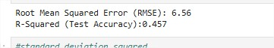

Source: (Author’s Own, 2025)
The figure 12 the model predicted accuracy evaluated on the test set using Root Mean Squared Error (RMSE) quantifying the average deviation of prediction also use R-Squared coefficient of determination to measure the proportion of variance in exam scores. Result of 0.45 almost approximately 5 points away from the actual score.

Medical Analysis

Figure 11. Variance, Covariance Matrix, Medical Score
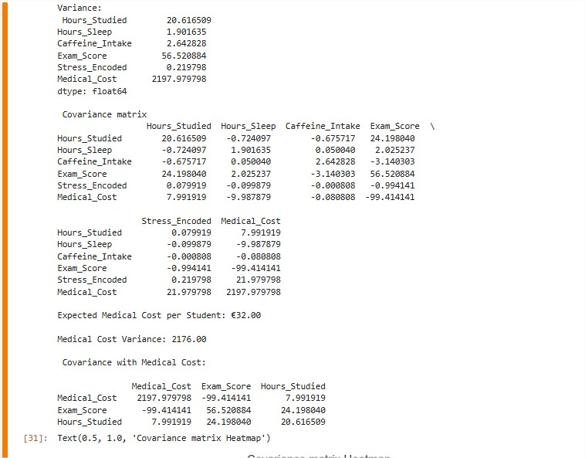

Source: (Author’s Own, 2025)
At figure 13 Evaluation of accuracy on the matrix of covariance tell us about two variables move together identify which factor impact the Exam Score, 24.20 the strongest positive predictor for study time (“Hours_Studied” vs “Exam_Score”), if the hours of studied increase the score too however the negative predictor Caffeine with value of -3.14 goes to opposite direction if caffeine (“Caffeine_Intake” vs “Exam_Score”) goes up the scores tend to go down.

Figure 12. Heatmap
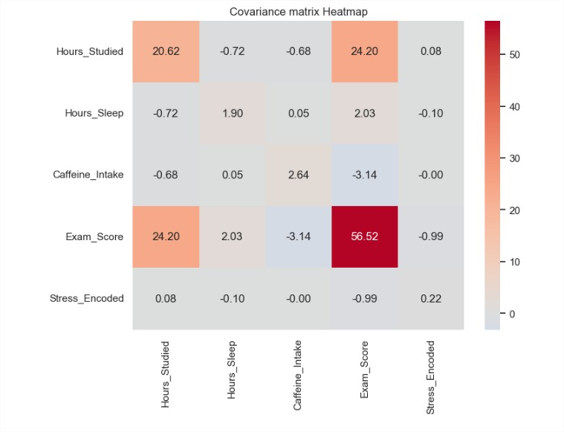

Source: (Author’s Own, 2025)
At figure 13 Heatmap or in matrix table figure 12 (“Hours_Sleep” vs “Exam_Score”) a positive “2. 03” covariance, means the students how sleep more tend to got high score but less than “24.20” important sleep but less impactful compare to study hours. Stressed students’ scores ((“Stressed_Encode” vs “Exam_Score”)) “- 0.99” we can infer is weaker the impact of caffeine, in conclusion students study more hours tend to sleep fewer hours that the results got in (“Hours_Studied” vs “Hours_Sleep”).
Has conclusion the matrix was used to support and findings to explore the strong predictor of factor exam performance.

References
Prosise, J. (2022) Applied Machine Learning and AI for Engineers. Sebastopol: O'Reilly Media.
Variance: GeeksforGeeks (n.d.) Python | Variance of List. Available at: https://www.geeksforgeeks.org/python/python-variance-of-list/ (Accessed: 19 December 2025).
Variance (Bias-Variance Tradeoff): Prosise, J. (2022) Applied Machine Learning and AI for Engineers. Sebastopol: O'Reilly Media, p. 27.
Covariance: GeeksforGeeks (n.d.) Python | numpy.cov() function. Available at: https://www.geeksforgeeks.org/python/python-numpy-cov-function/ (Accessed: 2 December 2025).
Covariance (Covariance Matrix): Prosise, J. (2022) Applied Machine Learning and AI for Engineers. Sebastopol: O'Reilly Media, p. 154.
Heatmap: GeeksforGeeks (n.d.) Seaborn Heatmap – A comprehensive guide. Available at: https://www.geeksforgeeks.org/python/seaborn-heatmap-a-comprehensive-guide/ (Accessed: 15 December 2025).
Heatmap (Visualization): Prosise, J. (2022) Applied Machine Learning and AI for Engineers. Sebastopol: O'Reilly Media, p. 19; p. 153.
ANOVA test: GeeksforGeeks (n.d.) How to Perform a One-Way ANOVA in Python. Available at: https://www.geeksforgeeks.org/python/how-to-perform-a-one-way-anova-in-python/ (Accessed: 3 December 2025).
Regression model: GeeksforGeeks (n.d.) Simple Linear Regression in Python. Available at: https://www.geeksforgeeks.org/machine-learning/simple-linear-regression-in-python/ (Accessed: 5 December 2025).
Regression Model: Prosise, J. (2022) Applied Machine Learning and AI for Engineers. Sebastopol: O'Reilly Media, pp. 59–69.
Bayes: GeeksforGeeks (n.d.) Bayesian Statistics & Probability. Available at: https://www.geeksforgeeks.org/data-science/power-of-bayesian-statistics-probability/ (Accessed: 8 December 2025).
Bayes (Naive Bayes / Bayes' Theorem): Prosise, J. (2022) Applied Machine Learning and AI for Engineers. Sebastopol: O'Reilly Media, p. 109.
RMSE: GeeksforGeeks (n.d.) Calculating RMSE Using Scikit-learn. Available at: https://www.geeksforgeeks.org/machine-learning/calculating-rmse-using-scikit-learn/ (Accessed: 18 December 2025).
RMSE (Root Mean Squared Error): Prosise, J. (2022) Applied Machine Learning and AI for Engineers. Sebastopol: O'Reilly Media, p. 64.
R-squared: GeeksforGeeks (n.d.) Python – Coefficient of Determination-R2 score. Available at: https://www.geeksforgeeks.org/machine-learning/python-coefficient-of-determination-r2-score/ (Accessed: 20 December 2025).
R-Squared (Coefficient of Determination): Prosise, J. (2022) Applied Machine Learning and AI for Engineers. Sebastopol: O'Reilly Media, p. 66.

